Component 2

student id  77275260

advanced software

Table of Contents

**Variable testing: 2**

**If condition testing: 3**

**Loop testing: 3**

**Unit testing: 4**

**Github screen shot: 5**

# Variable testing:

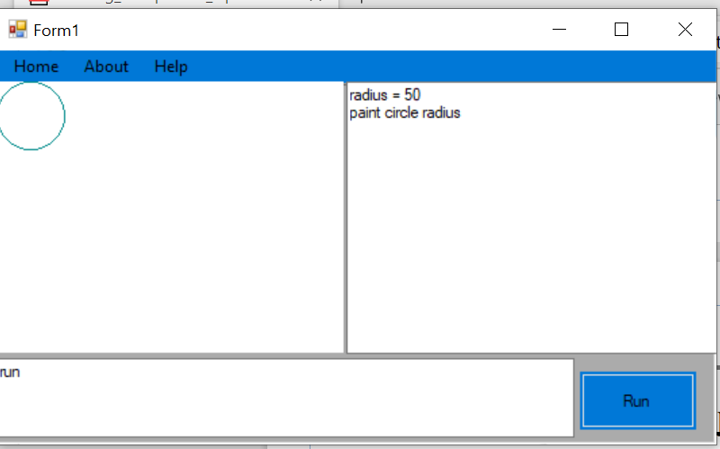

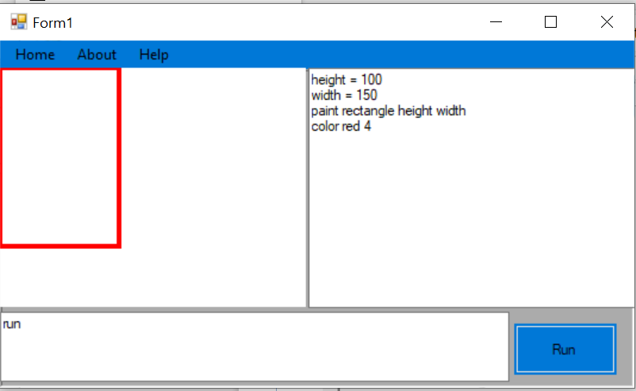

# If condition testing:

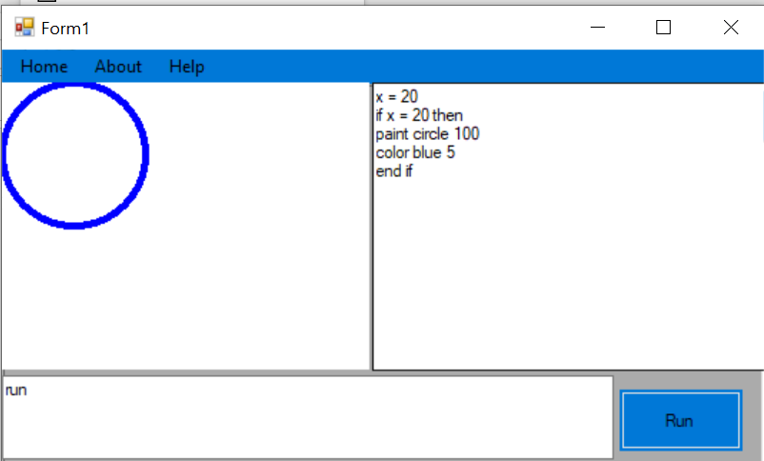

# Loop testing:

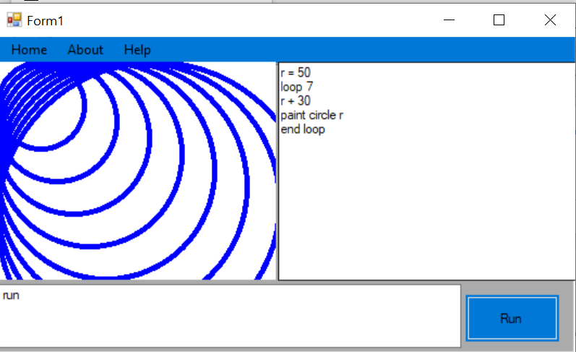

# Unit testing:

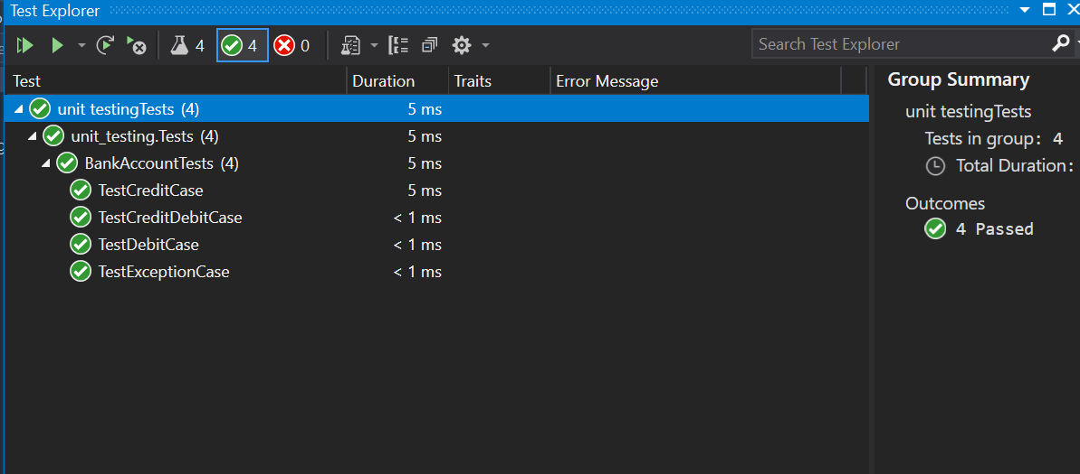

|  |  |  |  |  |  |  |  |  |  |  |  |  |  |
| --- | --- | --- | --- | --- | --- | --- | --- | --- | --- | --- | --- | --- | --- |
|  | | | | | | | | | | | | | |
| TEST CASE ID |  | | | | | | TEST CASE DESCRIPTION | | | | DRAW SHAPES USING VARIABLE IF CONDITION AND LOOP | | |
|  | | | | | | | | | | | | | |
| CREATED BY | | Rohit Chapagain | | REVIEWED BY |  | | | | | VERSION | | | 1.0 |
|  | | | | | | | | | | | | | |
| TESTERS`S NAME | | Rohit Chapagain | | TESTED DATE | 2021/8/12 | | | | | TEST RESULT | | | pass |
|  | | | | | | | | | | | | | |
| SN | PRE-REQUITIES | | | | |  | | | SN | TEST DATA | | | |
| 1 | Draw shapes using variable | | | | |  | | | 1 | R = 50  Paint circle R | | | |
| 2 | Draw multiple shapes with the help of loop | | | | |  | | | 2 | R = 50  Loop 7  R + 30  Paint circle R  End loop | | | |
| 3 | Draw shapes condition is true | | | | |  | | | 3 | X = 20  If x = 20 then  Paint circle 100  End if | | | |
|  | | | | | | | | | | | | | |
| TEST SCENARIO | | | Draw shapes using variable, if condition and loop | | | | | | | | | | |
|  | | | | | | | | | | | | | |
| SN | STEP DETAILS | | | | EXCEPTED | | | ACTUAL RESULT | | | | PASS, FAIL OR NOT EXECUTED | |
| 1 | Open application | | | | Application should run | | | As excepted | | | | Pass | |
| 2 | Declare variable and assign value and draw shape | | | | Command should entered | | | As excepted | | | | Pass | |
| 3 | Entered program to draw multiple shape using loop | | | | Command should entered | | | As excepted | | | | Pass | |
| 4 | Entered the command for loop statement if condition is true then draw shapes | | | | Command should entered | | | As excepted | | | | Pass | |
|  | | | | | | | | | | | | | |

# Github screen shot:

